

**Uzbekistan State World Languages University**

**Sustainable Purchase and Procurement Policy**

**Date policy approved: September 2021**

**Date for review of policy: August 2023**

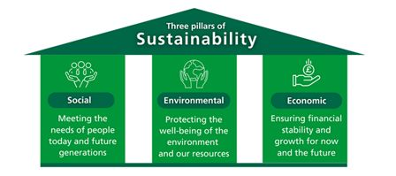Uzbekistan State World Languages University’s Sustainable Procurement Policies (Guidelines) outline the minimum sustainability requirements for product and service purchases and identify preferred, if not mandatory, product attributes. There are three pillars behind the notion of sustainability: economic, environmental, and social. This policy asserts that effective sustainable purchasing and procurement practices promote sustainable development and serve as key factors for the wise distribution and utilization of resources. As per the Brundtland Commission Report (1987), sustainable development is defined as “Development that meets the needs of the present without compromising the ability of future generations to meet their own needs.”

**Figure- 01 Three Pillars of Sustainability**

The university strictly adheres to these three pillars when purchasing and procuring goods and services. Sustainable procurement is seen as “smart” procurement, adopting a three-dimensional life-cycle approach (economic, environmental, and social) instead of a traditional one-dimensional, economics-focused approach. This three-dimensional approach does not require more time, nor is it necessarily more costly; rather, it represents strategic procurement at its best.

|  |  |
| --- | --- |
| ***Social*** | Human rights, access to clean drinking water, food security, fair pay and labor law protections, anti-child labor and forced labor laws, fair trade, health and safety, gender equality (including universal education), child mortality and maternal health, and overall well-being for all. |
| ***Environmental*** | Environmental resource management, urban planning, CO2 reduction, alternative energies (e.g., solar, wind), water management, sustainable agriculture, marine resources management, ecosystem protection, pollution, and waste management. |
| ***Economic*** | Economic regeneration, sustainable economic development, support for emerging markets, development of SMEs, total cost of ownership, life cycle costing, value for money, and poverty reduction. |

Uzbekistan State World Languages University factors in these criteria when purchasing and procuring goods and services. The policy is detailed across the following points:

1. **Financial**: The university aims to purchase efficient and sustainable goods and services to reduce costs.
   * Identify and develop markets for sustainable solutions.
   * Increase competitiveness by raising demand for sustainable solutions.
   * Strive for innovative, sustainable solutions.
   * Implement cost savings through life-cycle costing over the long term.
   * Minimize disposal costs and the environmental impact of products at the end of their life cycle.
2. **Risk Management**: Proactively assesses economic, legal, environmental, and social sustainability risks and develops strategies to manage them.
3. **Commitment to Sustainable Goals**: The university aligns its organizational culture, values, and ethics with relevant policies before procurement. Priorities are clearly stated in the policy and reflected in procurement practices.
4. **Response to Stakeholders' Expectations**: Uzbekistan State World Languages University prioritizes social and sustainable responsibilities beyond mandatory requirements, addressing environmental and social issues.
5. **Social Responsibility**: The university is dedicated to fulfilling social and sustainable responsibilities to enhance competitiveness, attract investors, strengthen labor markets, and encourage reputable organizations to bid.

These guidelines are intended for use by the university’s purchasing and procurement department, as well as other relevant faculties and departments. The guidelines educate personnel on required and preferred sustainable criteria (Green, economically, and socially responsible) to be included in bids and reporting, facilitating negotiations on pricing.

**Procurement Process**:

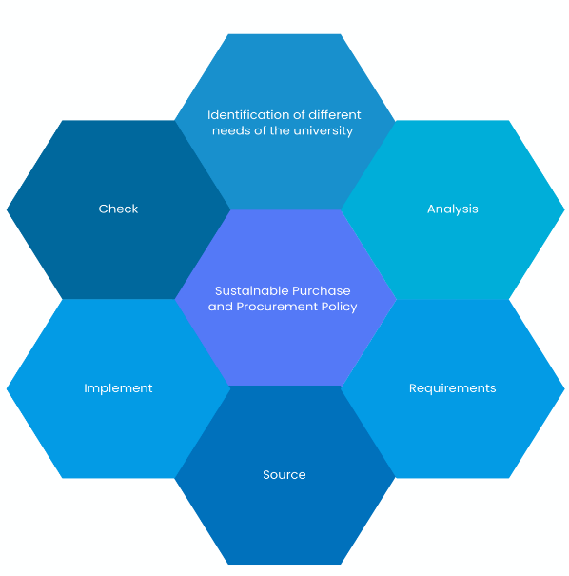The university’s procurement process includes: identification of needs, planning, preparation of specifications, budget considerations, selection of goods, contract awarding, and contract management.

**Figure-02 Shows sustainable purchasing and procurement method**

**Identification**: Key requirements are identified based on economic, environmental, and social indicators, including:

* University policies on economic, environmental, and social sustainability.
* Community needs and expectations.
* Environmental risks (natural).
* Environmental and social assessments.

**Analyze Sustainability Needs**: Personnel involved in purchasing and procurement research and analyze the supply market to ensure appropriate market options and selection methods.

The strategy includes:

1. Findings on sustainable procurement needs, opportunities, and risks.
2. Actions for managing key risks and opportunities.
3. Demand-related approaches (reduce, reuse, recycle).
4. Sourcing strategies for sustainable procurement objectives.
5. Prequalification and selection of bids/proposals.
6. Sustainability evaluation criteria.
7. Expected sustainability benefits.
8. Impact of sustainability on procurement and budget.

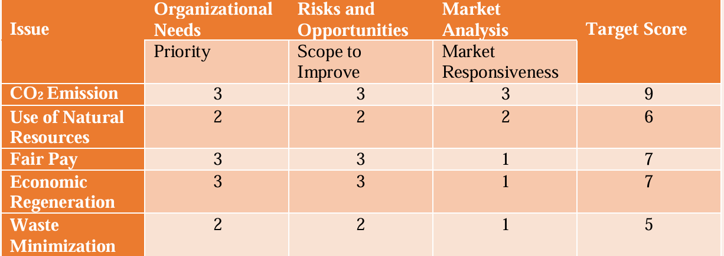**Sustainability Score Matrix**: Issues are ranked and categorized into three priorities: Low, Moderate, and High. This matrix helps the university address goals like reducing carbon emissions, fair pay, and economic regeneration.

**Source:** At this stage, the university’s procurement process deals with approaching the market, decisions on when to include sustainable criteria and full bids, identifying the most advantageous bid proposal, and awarding the contract. It is important that the procurement documents clearly describe the sustainability evaluation criteria so that suppliers are informed on how their proposals would be evaluated against them. For this purpose, buyer may organize a pre-bid supplier briefing. The purpose of this to give prior notice to the potential suppliers about the procurement and inform them about sustainability priorities.

University’s purchase department will set out criteria to evaluate the bids/ proposals. This methodology includes.

1. Qualifying Criteria

2. Rated Criteria

3. Monetary Quantifiable Criteria

The supplier with the best sustainable procurement solution may not always be the successful Bidder/Proposer if they are not competitive in other areas. It is important that the whole of their Bid/Proposal is assessed on all criteria to determine the best fit-for-purpose solution.

**Implement**: The designated office at Uzbekistan State World Languages University ought to proactively manage the contract to ensure that the sustainability priorities are delivered, as agreed. They should select an appropriate approach to manage contract implementation, and developing a comprehensive contract management plan to foster a productive relationship with the supplier is essential. The contract management plan should be finalized collaboratively to include performance targets and measures. The contract manager and supplier should revisit the established sustainable procurement risk profile throughout the planning and selection stages.

**Check**: This stage includes activities to review and assess delivery, ensuring that sustainability outcomes and priorities were met. Part of this process may involve debriefing the supplier and key stakeholders on successes and areas for improvement. Lessons learned should be shared among all parties involved to enhance future contract performance.