**LESSON 1**

|  |  |
| --- | --- |
| **Theme № 1** | **Writing. Introduction to the essay writing. Organizing and developing essay: introduction, body paragraph, conclusion.** |

|  |  |
| --- | --- |
| **Length: One hour and twenty minutes** | **Number of students: 15** |
| Lesson Outline   1. Lead-in 2. Task 1 Finding features of academic essay 3. Task 2 Leaning about the structure of an academic essay 4. Task 3 Getting acquainted with introduction parts. 5. Task 4 Developing body paragraph writing skills. 6. Task 5 Identifying purpose of conclusion. 7. Summary and Homework | |
| **The aіm: To get a clear idea about structure of the five-paragraph essay; to • coherence and unity in paragraphs and essays** | |
| Objectives:   * to introduce learners to essay writing (essay structure, types); * to give students an opportunity to explore parts of and academic essay; * to enable learners to practice essay writing; * to give students guided practice on introduction writing. | |
| **Activity Type:** | **Individual, small group, whole class (teacher-students)** |

**Lead-in: (5-10 min)**

Distribute handout 1 and ask students to discuss the question in pairs. Then discuss them with the whole group.

**Handout 2;**

**Task 1 Introduction to academic essay writing**

Objective: To introduce to academic essay writing

Time: 5 minutes

Materials: handout 2 task 1

Procedure:

* Ask students read the information and find the features of academic essay
* Short discussion about the characteristics of academic essay.

**Handout 3**

**Task 2 Focus on an academic essay structure (parts, number of paragraphs)**

Objective: to introduce the 5 paragraphed essay outline

Time: 20 minutes

Materials: handout 2

Procedure:

* Make a short introduction to an academic essay;
* Distribute handout 3 and ask the learners to read the essay model and notice how the essay is organized;
* Then respond to the questions in exercise B.

**Handout 4;**

**Task 3 Examining an introduction**

Objective: to introduce the components of an Introduction

Time: 15 minutes

Materials: handout 4

Procedure:

* Ask the students to read the model introductory paragraph in handout 4 and then ask them, break the statements into hook, background information and thesis statement;
* After ask the learners in pairs to read the paragraph again and answer the following questions;
* As soon as they finish go around and check the answers.

**Handout 5**

**Task 4 Examining body paragraphs**

Objective: to introduce the components of a body paragraph

Time: 15 minutes

Materials: handout 5

Procedure:

* Ask the students to examine the boy paragraphs of the essay “Becoming an Academic Writer” in handout 4 and then ask them to respond to the questions and statements below;
* Then ask the learners to compare their answers with a partner;
* As soon as they finish check the answers with a whole group.

**Handout 6**

**Task 5 Examining a Conclusion**

Objective: to introduce the components of concluding paragraph

Time: 10 minutes

Materials: handout 6

Procedure:

* Ask the students to examine the concluding paragraphs of the essay “Becoming an Academic Writer” in handout 4 and then ask them to respond to the questions and statements below;
* Then ask the learners to compare their answers with a partner;
* As soon as they finish check the answers with a whole group.

**Summarizing: (10 minutes)**

**Discuss the topic with the whole group. Summarize the activity by giving final comments.**

**Resource:**

1. Jason Davis and Rhonda Liss, Effective Academic Writing, The Essay, book 3.

**Materials for the lesson:**

**Handout 1**

**Lead-in: Thinking about the topic**

Discuss the pictures with a partner.

• What types of writing are the people in the pictures practicing?

• What types of writing do you do in your leisure time?

• What types of writing do people do in professional settings?

• What are some of the challenges you face when you write?

 

 

**Handout 2.**

**Task 1. Rhetorical Focus: Read the text below and find the features of academic essays.**

|  |
| --- |
| **The Academic Researched Essay**  You may have written short essays, but as you progress in your academic studies, your teachers will expect longer essays that have been well researched. These essays have greater elaboration, which may include examples, statistics, questions, definitions, quotations, and anecdotes. Researched essays are more analytical in nature.  Like other essays, the researched essay has three basic parts: an introduction, a body, and a conclusion. Each body paragraph contains a topic sentence that supports the thesis statement. Facts found in research, quotations from experts, and statistics all support the body paragraphs to strengthen the essay’s message. |

**Handout 3**

**Task 2 Reading an essay**

1. **Read the essay below about becoming an academic writer. Notice how the essay is organized. Then answer the questions given below.**

|  |
| --- |
| Learning how to write an academic essay is essential for students who are planning to attend college. Most professors require critiques of books and films, research papers, and formal reports related to the content of their courses. When I first started college, I was excited about facing these challenges and pursuing my major, media and communications. I was determined to improve my writing. To achieve this goal, I focused on three points: the content of an essay, correct grammar, and advanced level vocabulary.  As soon as I started to write for college, I realized that college writing was different from the writing I was used to doing. In high school, most of my writing dealt with my personal experiences. I wrote mainly about my family, childhood, and friends. In contrast, college writing focused on a variety of issues that I was unfamiliar with, such as reacting to a piece of literature or writing about the community. Therefore, the most important thing for me was to understand the assigned topic before attempting my first draft. In some cases, I would have to read and do research to build a foundation. I wanted to include examples, statistics, and direct quotations whenever possible to support my opinions. By giving specific examples, I realized that my essays became more detailed, easier to read, and much more interesting. However, grammatical problems in my writing were still an issue.  I realized that I had to improve my understanding of grammar in order to write for college. Before I came to college, grammar was not my strong point. For example, I often created run-on sentences or sentence fragments. I was more concerned with what I wanted to say than with how it was said. In fact, my professors would not accept this type of writing and made me revise many times. Consequently, I made grammar my second priority. I reviewed the basic grammatical structures such as subjects and verbs and checked all my work for verb tense consistency and punctuation. As a result, my sentences became more complex because I included transitional words, gerunds, and embedded clauses. The more I wrote, the more my writing improved.  Furthermore, because I was accustomed to writing letters and informal essays, I usually wrote the way I spoke with my family and friends. It was quite common for me to include slang and abbreviated terms, which were appropriate in social contexts but were unacceptable in formal essays. I soon realized that academic writing required a much more sophisticated vocabulary. Not surprisingly, improving my vocabulary became my third and final goal. Thus, I bought a new dictionary and thesaurus to help expand my knowledge. I became more aware of how often I repeated the same words and phrases throughout my essay. I often searched for synonyms to replace words that I thought were too simple for a college essay. I also focused more on the rules of spelling and corrected any errors I found before submitting my assignment to the instructor.  Academic writing requires critical thinking skills, an understanding of the topic, high level vocabulary, and correct grammar. Having these skills is empowering since it has made me a better communicator and student. I have come a long way since I started college, and I am now proud of the writing that I produce. |

**B) Answer the questions and respond to the statements below.**

1. Underline the thesis statement in the introduction. What three points does the

writer suggest that he or she will make in the essay?

___________________________________________________________________________________________________________________________________

2. How does body paragraph 1 relate to the thesis statement? ___________________________________________________________________________________________________________________________________

3. How does body paragraph 2 relate to the thesis statement? ____________________________________________________________________________________________________________________________________

4. How does body paragraph 3 relate to the thesis statement?

____________________________________________________________________________________________________________________________________

5. What does the conclusion tell readers about the importance of this topic to the

writer? ___________________________________________________________________________________________________________________________________

**Handout 4**

**Task 3 A) Rhetorical focus: What are the parts of academic essay?**

|  |
| --- |
| **The Introduction**  An academic essay’s introduction must have a hook, background information,  and a thesis statement.  **Hook**  A hook is a statement that begins the introduction. It includes one or two interesting sentences that engage the readers’ attention and stimulate their curiosity. The sentences below provide the hook for an essay about an conomic crisis.  *Henry Paulson's expression turned to horror as he looked down at the numbers. He suddenly realized that the market was on the verge of collapse.*  **Background Information**  The background information contains a general statement or statements that give a broad picture of the subject matter to be discussed. They provide extra information to help the reader understand the content of the essay. The sentences below provide the context (situation) for an essay on the economic crisis of 2008.  *In September 2008 the banking system in the United States nearly collapsed, leading to what many considered to be the worst economic crisis since the Great Depression of the 1930s.*  **Thesis Statement**  A thesis statement usually comes at the end of the introduction. It summarizes what the entire essay is about. It contains the topic and the controlling idea for the whole essay. The topic is the subject matter of the essay. The controlling idea defines the purpose of the essay and sets its direction.  **topic and controlling idea:**  *The economic crisis could have been avoided with banking regulations.* |

1. **Read this introduction to an essay. Then answer the following questions.**

**The Risks of Social Media**

Today there are more social networking accounts than there are people on the planet. Social networking allows people to share ideas with friends and family everywhere. It connects people in ways that were never possible in the past. Still, users of these sites should be cautious. Social media can be dangerous.

1. Circle and label the hook. How does it engage readers? _______________________________________________________________

2. Underline the background information. What information does it provide to help

readers understand what will follow?

3. Underline the thesis statement. Based on the thesis statement, what do you think the essay will be about? ____________________________________________________________________________________________________________________________________

4. What is the topic of the thesis statement?

________________________________________________________________

5. What is the controlling idea of the thesis statement? ____________________________________________________________________________________________________________________________

**Handout 5**

**Task 4 A) Rhetorical focus: How are the body paragraphs structured?**

|  |
| --- |
| **Body Paragraphs**  The body paragraphs contain the supporting details of the essay.  • The topic sentence clearly states the content of each paragraph. It supports and expands on an aspect of the topic and controlling idea of the essay’s thesis statement. The topic sentence is often the first sentence of a body paragraph.  • Each body paragraph must develop a point presented in the topic statement. All the supporting details in a body paragraph must clearly relate to each other. They can be descriptions, definitions, examples, anecdotes, statistics, or quotations. Quotations may come from a published work or from a personal interview.  • The concluding sentence may either bring the idea of the paragraph to a close or suggest the content of the next paragraph. |

1. **Examining body paragraphs**

Examine the body paragraph of the essay, “Becoming an Academic Writer”. Then respond to the questions and statements below. Compare your answers with a partner.

Body Paragraph 1

1. Circle the topic sentence.

2. What supporting details does the writer give? How do these details support the

topic sentence?

_________________________________________________________________

3. The concluding sentence_____

a. brings the idea of the paragraph to a close.

b. suggests the content of the next paragraph.

Body Paragraph 2

1. Circle the topic sentence.

2. What supporting details does the writer provide? How do these details support

the topic sentence?

________________________________________________ ________

3. The concluding sentence_____

a. brings the idea of the paragraph to a close.

b. suggests the content of the next paragraph.

Body Paragraph 3

1. Circle the topic sentence.

2. What supporting details does the writer provide? How do these details support

the topic sentence?

_________________________________________________________________

3. The concluding sentence_____

a. brings the idea of the paragraph to a close.

b. suggests the content of the next paragraph.

**Handout 6 Task 5**

1. **Rhetorical focus: What is the role of conclusion in the essay?**

|  |
| --- |
| **The Conclusion:**  • The conclusion is usually two to four sentences in length.  •It restates the essays thesis in different words. This restatement connects the conclusion to the introduction.  • It may give advice or a warning.  • It may make a prediction or ask a question.  • It can provide new insights and discoveries that the writer has gained. |

1. **Examining a conclusion**

**Reread the conclusion of “Becoming an Academic Writer”. Then respond to the questions and statements below.**

Academic writing requires critical thinking skills, an understanding of the topic, research, high-level vocabulary, and correct grammar. Having these skills is empowering since it has made me a better communicator and student. I have come a long way since I started college, and I am now proud of the writing that I produce.

1. How many sentences appear in the conclusion?

2. Underline the sentence in the conclusion that restates the thesis in the introduction.

3. The conclusion ends with_____

a. some advice.

b. a prediction.

c. a warning.

d. an insight.

|  |  |
| --- | --- |
| **☺☺☺**  **(10 min)** | |
|  |  |

**Discuss the topic with the whole group. Summarize the activity by giving final comments.**

**Homework: Exercise 1; Exercise 2.**

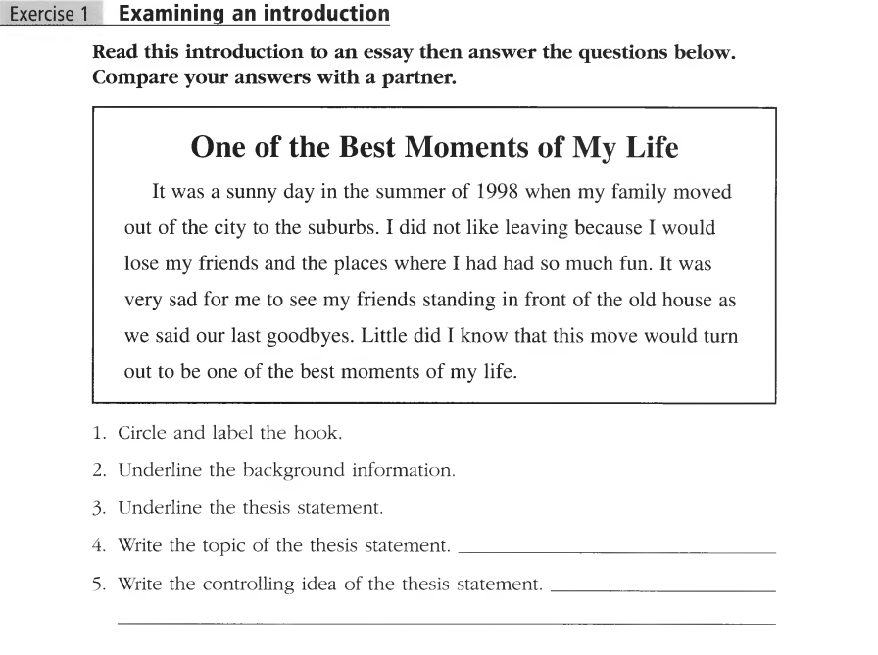

**Task 2.**

**Read the rhetorical focus about the Unity and Coherence. Then answer the questions given below.**

1. What is a unity in writing?
2. Why is it important?

