**Regarding the Conduct of the “Brain-Ring” Intellectual Competition  
Organized within the Framework of the “Youth Month”  
by the Primary Organization of the Youth Union  
at Uzbekistan State World Languages University**

**2025 march Tashkent City**

**Chairperson -** First Vice-Rector for Youth Affairs and Spiritual-Educational Work, **V. Sadiyev**

**Participants:**V. Sadiyev – First Vice-Rector for Youth Affairs and Spiritual-Educational Work  
D. Khamdamov – Head of the Department for Work with Youth, Spirituality and Enlightenment  
Coordinators of the Primary Organization of the Youth Union, Deputy Deans and Tutors

**AGENDA:**

1. Conducting the “Brain-Ring” competition as part of the “Intellectual Projects and Reading Culture” week, organized within the framework of the university’s “Youth Month.”
2. Reflections on the outcome of the competition and the awarding of students who emerged as winners.

The Youth Union Primary Organization of the Uzbekistan State University of World Languages declared the period from February 25 to March 25, 2025, as "Youth Month" at the university level. Within the framework of this month, an "Intellectual Projects and Reading" week was organized to enhance students' intellectual potential, foster a culture of reading, strengthen teamwork skills, and develop logical thinking abilities.

As part of this week, an intellectual competition titled "Brain-Ring" was held among young participants. The competition aimed to expand students’ knowledge, improve literacy in history, literature, culture, and science, and create an atmosphere of friendly competition among university students. The event was inaugurated by V. Sadiyev, who, in their speech, spoke about "Youth Month," highlighted the reforms implemented by the President to develop young people's intellectual capacity, emphasized the increasing popularity of "Brain-Ring" competitions in higher education institutions, and wished the participants success.

The competition featured 20 teams representing various faculties of the university, engaging in intense debates to test their knowledge. The event comprised four stages, with each stage presenting questions across different disciplines. Participants demonstrated their proficiency in teamwork, logical reasoning, and rapid decision-making. Throughout the competition, discussions took place in a spirit of camaraderie, knowledge exchange, and collaborative engagement.

At the conclusion of the event, participants shared their impressions and proposed the regular organization of such competitions while expanding their thematic scope. The highest-achieving contestants were selected for the university's "Brain-Ring" team. The panel of expert judges evaluated the best-performing participants based on criteria established in the competition regulations.

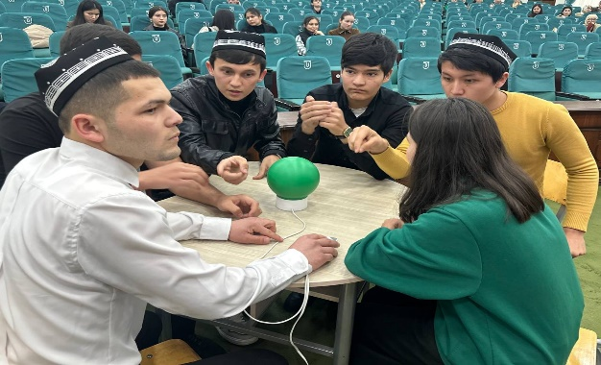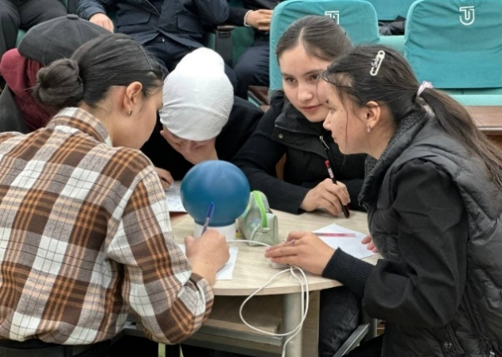

Based on the competition results, the Organizational Working Group has issued the following decision:

1. According to the competition outcomes, the following teams have secured victory:

* **1st place** — “*Boylarga Mazza”* team
* **2nd place** — “O*‘zbekiya”* team
* **3rd place** — “*Turon”* team

Based on the order of the university rector dated February 22, 2025, No. 85/11-08, the winners of the first, second, and third places (as listed in the attached document) shall be awarded diplomas by the university. In accordance with the regulations, the first-place winner shall receive a financial incentive equal to three times the base scholarship, the second-place winner shall receive an amount equal to twice the base scholarship, and the third-place winner shall receive an amount equal to the base scholarship. These financial incentives will be provided from the university’s student encouragement fund, which is formed through both budgetary and non-budgetary payment-contract resources.

1. Moving forward, the university shall expand intellectual projects, ensure the regular organization of “*Brain-Ring”* competitions, and enhance students' social engagement by systematically holding such events.

Chairperson of the Working Group: **V. Sadiyev**  
Secretary: **M. Sabirov**