**On the Intellectual Competition "Erudit-Kvartet" organized within the framework of "Youth Month" (Yoshlar oyligi)by the Primary Organization of the Youth Union at the Uzbek State World Languages University**

**PROTOCOL**

**February 2025 Tashkent City**

**Chairperson:**

First Vice-Rector for Youth Affairs and Spiritual-Educational Work – V. Sadiyev

**Participants:**

V. Sadiyev – First Vice-Rector for Youth Affairs and Spiritual-Educational Work, D. Khamdamov – Head of the Department for Youth Work, Spirituality, and Enlightenment, Coordinators of the Youth Union’s Primary Organization, Deputy Deans, Tutors

**AGENDA:**

**1. Conducting the “Erudit-Kvartet” intellectual competition within the “Week of** Intellectual Projects and Reading” organized as part of the “Youth Month” at the university.

2. Sharing thoughts on the results of the competition and awarding the winners.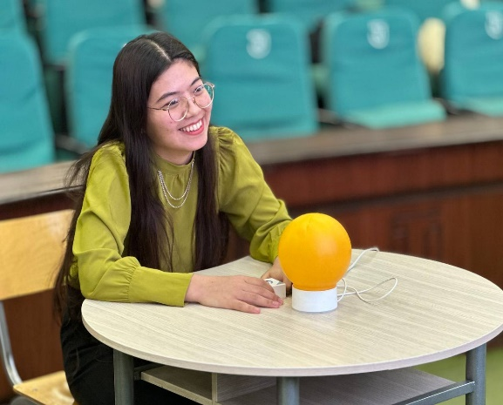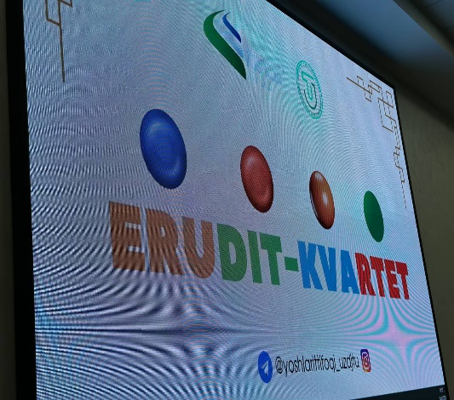

**HEARD:**

It was announced that the period from February 25 to March 25, 2025, was declared “Youth Month” at the Uzbek State World Languages University by the Youth Union’s Primary Organization. As part of this initiative, the “Week of Intellectual Projects and Reading” was held to enhance students’ intellectual potential, promote reading culture, strengthen teamwork skills, and improve logical thinking abilities.

Within the framework of this week, the “Erudit-Kvartet” intellectual competition was organized among students. The goal of the competition was to broaden students’ knowledge, increase their literacy in history, literature, culture, and science, foster a friendly competitive environment among university students, and develop their intellectual capacity.

The competition was opened by S. Islomova, who spoke about the significance of “Youth Month,” the reforms carried out by the President aimed at developing youth’s intellectual potential, and noted the growing popularity of “Erudit-Kvartet” competitions in higher education institutions. She wished all participants success.

The competition involved one representative from each of 20 teams from various university faculties. The participants engaged in dynamic debates to test their knowledge. The competition consisted of four stages, with each round covering different fields. The teams demonstrated their skills in teamwork, logical thinking, quick decision-making, and broad general knowledge. The event took place in a friendly atmosphere of knowledge exchange and collaboration.

At the end of the event, participants shared their impressions and proposed that such competitions be held regularly and with broader topics. The jury, composed of specialists responsible for conducting the competition, evaluated the participants according to the criteria outlined in the Regulations.

**DECIDED:**

1. Based on the results of the competition, the following participants were declared winners:

1st Place – “MantIQ” team

2nd Place – “TUZ” team

3rd Place – “Cognitives” team

According to the Rector’s order No. 85/11-08 dated February 22, 2025, the winners of 1st, 2nd, and 3rd places (as specified in the attachment) shall be awarded diplomas by the university. In accordance with the Regulations, they shall also be financially rewarded from the university’s student incentive fund formed from both budgetary and extrabudgetary contract payments, as follows:

1st place – an amount equal to three times the base scholarship,

2nd place – an amount equal to two times the base scholarship,

3rd place – an amount equal to one time the base scholarship.

2. To further enhance intellectual projects at the university, the “Erudit-Kvartet” competition shall be held regularly to promote students’ social engagement.

Head of the Organizing Committee: V. Sadiyev

Secretary: M. Sabirov