**Report on the Football Tournament Held within the Framework of "Sports Week"  
by the Youth Union Primary Organization of the Uzbekistan State University of World Languages**

**2025 march Tashkent City**

**Chairperson -** First Vice-Rector for Youth Affairs and Spiritual-Educational Work, **V. Sadiyev**

**Participants:**V. Sadiyev – First Vice-Rector for Youth Affairs and Spiritual-Educational Work  
D. Khamdamov – Head of the Department for Work with Youth, Spirituality and Enlightenment Coordinators of the Primary Organization of the Youth Union, Faculty Members of the Department of Physical Culture and Sports, Deputy Deans and Tutors

**Agenda:**

1. **Organization of the Football Tournament** within the framework of "Sports Week," held as part of "Youth Month" at the university.
2. **Reflections on the conclusion of the tournament** and the recognition of students who achieved victory in the competition.

**Heard:**

The Youth Union Primary Organization of the Uzbekistan State University of World Languages declared the period from February 25 to March 25, 2025, as "Youth Month" at the university level. Within this framework, a "Sports Week" was organized to enhance students' physical activity, develop teamwork skills, and foster interest in sports.

As part of this initiative, the Youth Union held a football tournament at the university. The primary objectives of the competition were to enhance students' physical well-being, promote sports participation, and foster a spirit of friendly competition among university students. The tournament aimed to encourage students to participate in sports, advocate for physical education and a healthy lifestyle, and cultivate a collective team spirit within the university.

Ten teams from various faculties participated in the competition. The tournament consisted of several phases, including the group stage, semi-finals, and final matches. Each team approached their games with rigorous preparation. Throughout the tournament, participants were assessed not only on their athletic skills but also on their mental resilience and physical endurance.

The matches were highly competitive and intense, with teams striving for excellence at each stage. The competition consisted of four rounds, each testing the teams' abilities and teamwork. Every team mobilized its full potential to achieve leadership in its respective field, demonstrating that sports serve as more than just a game—they are also a means of fostering mutual respect and collaboration among students.

Throughout the tournament, discussions were carried out in a spirit of camaraderie, physical engagement, and collective teamwork. Participants not only displayed their technical and tactical skills but also emphasized mutual respect and sportsmanship. At the conclusion of the event, participants shared their impressions and proposed the regular organization of such competitions.

The top-performing contestants were evaluated by a panel of expert judges based on criteria established in the competition regulations.

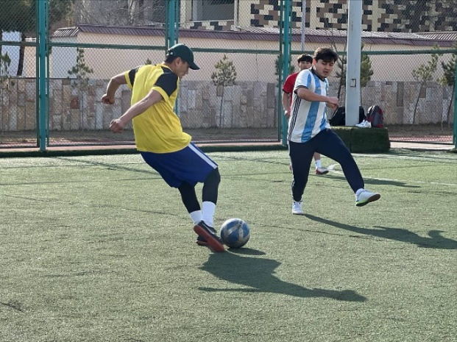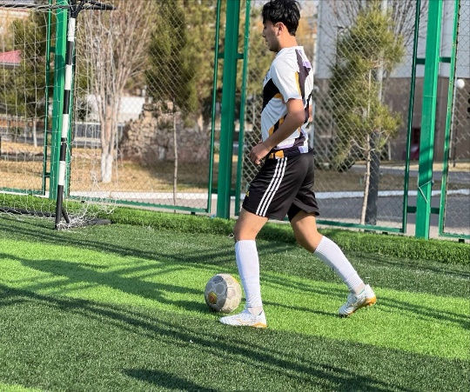

Based on the competition results, the Organizational Working Group **resolves** the following:

1. **Winners of the competition:**

* **1st place** — *Faculty of International Journalism Team*
* **2nd place** — *Faculty of English Language (First Faculty) Team*
* **3rd place** — *Faculty of Romance-Germanic Languages Team*

In accordance with the university rector’s order dated February 22, 2025 (No. 85/11-08), the winners of first, second, and third place (as per the attached list) shall be awarded diplomas by the university. Furthermore, as per the competition regulations, the financial incentives shall be distributed as follows:

* **1st place winners** shall receive **three times** the amount of the base scholarship.
* **2nd place winners** shall receive **twice** the amount of the base scholarship.
* **3rd place winners** shall receive an amount **equal to** the base scholarship.  
  These incentives shall be provided from the university’s student encouragement fund, formed through both budgetary and non-budgetary payment-contract resources.

1. To expand sports competitions within the university, ensure the regular **organization of football tournaments**, and promote students' physical activity, these events shall continue to be held systematically.

1. **The selection of new members for the university football team will be carried out among the top-performing participants in the tournament, and their training will** be further developed.

**Chairperson of the Working Group:** **V. Sadiyev**  
**Secretary:** **M. Sabirov**