**REPORT**

Regarding the Volleyball Tournament held within the framework of the “Youth Month” organized by the Primary Organization of the Youth Union of Uzbekistan State World Languages University.

**March 2025 | Tashkent City**

**Chairperson:**  
First Vice-Rector for Youth Affairs and Spiritual-Educational Work – V. Sadiyev.

**Participants: V. Sadiyev** – First Vice-Rector for Youth Affairs and Spiritual-Educational Work,**D. Khamdamov** – Head of the Department for Youth Work, Spirituality, and Enlightenment, Coordinators of the Primary Organization of the Youth Union,  
Instructors from the Department of Physical Education and Sports,  
Deputy Deans, Tutors.

**ON THE AGENDA** **:**

1. **Holding the Volleyball Tournament** within the framework of the “Sports Week” organized as part of the “Youth Month” at the university.

2. **Feedback on the competition results** and **awarding of students who won the tournament**.

**HEARD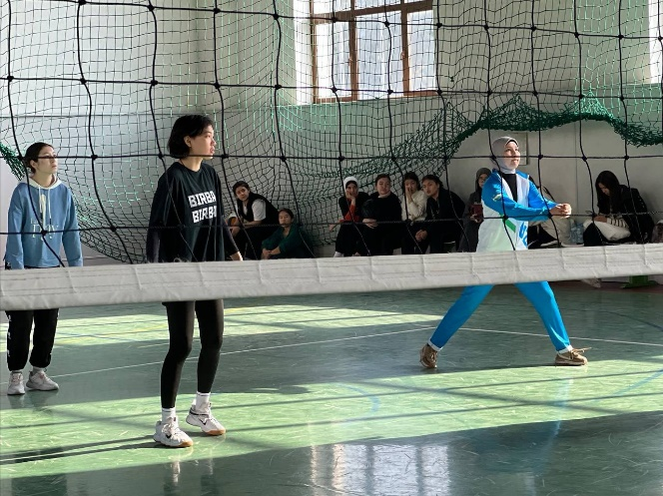:** At Uzbekistan State World Languages University, the Primary Organization of the Youth Union declared the period from **February 25 to March 25, 2025** as **“Youth Month”**. As part of this initiative, a **“Sports Week”** was organized with the aim of enhancing students’ physical activity, developing teamwork skills, and increasing interest in sports. .As part of this week-long initiative, a **university-wide Volleyball Tournament** was held by the Youth Union. The tournament was organized to **strengthen students' physical well-being**, **increase interest in sports**, and **foster a spirit of friendly competition among university students**.

The tournament was officially opened by **S. Islamova**, who, in her speech, highlighted the importance of “Youth Month,” spoke about the **reforms implemented by the President to enhance youth physical development**, and emphasized the **growing popularity of sports competitions in higher education institutions**. She also wished the participants success.

A total of **10 teams from various university faculties** participated in the tournament. The teams showcased their **physical strength, quick thinking, and rapid decision-making skills**. Throughout the competition, a **friendly atmosphere**, **physical activity**, and **team collaboration** were strongly evident.

At the end of the event, participants **shared their impressions** and **expressed suggestions** for regularly organizing such tournaments in the future.

At the conclusion of the competition, participants who achieved the highest results were evaluated by the **Judging Panel**, consisting of specialists responsible for organizing the tournament, based on the **criteria set forth in the official regulations**.Tanlov yakunida eng yaxshi natija ko‘rsatgan ishtirokchilar Tanlovni o‘tkazish bo‘yicha mutaxassislardan iborat Hakamlar hay’ati aʼzolari Nizomda belgilangan mezonlar asosida baholandi.

### ****Based on the results, the Organizing Working Group RESOLVED:****

**According to the competition results, the following teams were declared winners:**

**1st place** – Faculty of Translation Studies

**2nd place** – English Language Faculty I

**3rd place** – Faculty of Roman-Germanic Philology

In accordance with **Order No. 85/11-08 dated February 22, 2025** of the University Rector, the winners of the 1st, 2nd, and 3rd places (as listed in the appendix) shall be **awarded diplomas** by the university and, in accordance with the regulation:

The **1st place team** shall receive a **monetary incentive equal to 3 times the basic scholarship**,

The **2nd place team** shall receive **2 times the basic scholarship**,

The **3rd place team** shall receive **1 time the basic scholarship**,

These incentives shall be funded from the university’s **student incentive fund**, formed from both **budgetary and extra-budgetary (tuition) resources**.

To **expand sports competitions** at the university in the future, ensure that **volleyball tournaments are held regularly**, and to **enhance student physical activity**, it is resolved that such competitions be organized on a **consistent basis**.

**Head of the Working Group:**   **V. Sadiyev**  
**Secretary:**           **M. Sabirov**