### REPORT

**Regarding the “Zakovat” Intellectual Competition held within the framework of the “Youth Month” organized by the Primary Organization of the Youth Union at Uzbekistan State World Languages University**

**2February 2025**                  **Tashkent City**

**Chairperson:**  
V. Sadiyev – First Vice-Rector for Youth Affairs and Spiritual-Educational Work

**Participants:**

V. Sadiyev – First Vice-Rector for Youth Affairs and Spiritual-Educational Work, D. Khamdamov – Head of the Department for Youth Work, Spirituality, and Enlightenment,Coordinators of the Primary Organization of the Youth Union,Deputy Deans andTutors

**ON THE AGENDA** **:**

1.Conducting the “Zakovat” competition as part of the “Intellectual Projects and Reading Week” held within the framework of “Youth Month” at the university.

2.Discussion of the competition outcomes and awarding of students who emerged as winners.

### ****HEARD:****

At Uzbekistan State World Languages University, the Primary Organization of the Youth Union declared the period from **February 25 to March 25, 2025** as **“Youth Month.”** As part of this initiative, an **“Intellectual Projects and Reading Week”** was organized with the aim of **enhancing students’ intellectual potential**, **cultivating a reading culture**, **developing teamwork skills**, and **strengthening logical thinking abilities**.

Within the framework of this week, an intellectual competition titled **“Zakovat”** was held among the youth. The goal of the competition was to **broaden students’ knowledge**, **increase their literacy in history, literature, culture, and science**, and to foster a **spirit of friendly competition** among university students.

The competition was officially opened by **S. Islamova**, who in her speech emphasized the **significance of Youth Month**, spoke about the **ongoing reforms implemented by the President to promote intellectual development among youth**, and acknowledged the **growing popularity of Zakovat competitions in higher education institutions**. She also wished the participants success.

A total of **20 teams from various faculties** participated in the competition. The teams engaged in **intense rounds of debate**, testing their knowledge and skills. The competition consisted of **3 stages**, with questions covering a range of subjects in each stage. Participants demonstrated their abilities in **teamwork, logical reasoning, quick decision-making, and broad-based knowledge**.

Throughout the event, **an atmosphere of camaraderie, knowledge exchange, and collaboration** prevailed. At the conclusion of the competition, participants shared their impressions and offered suggestions to **increase the frequency of such events** and **expand the thematic scope** of future. 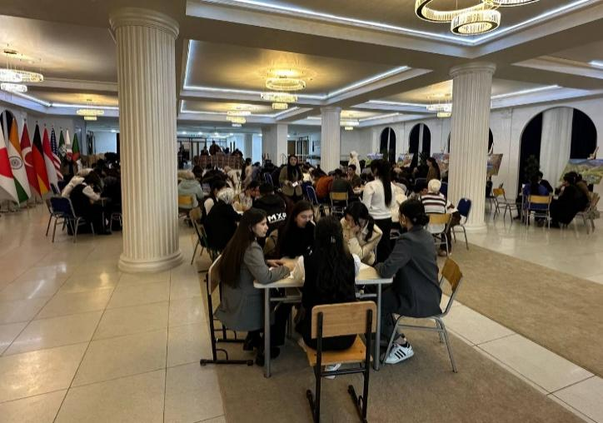

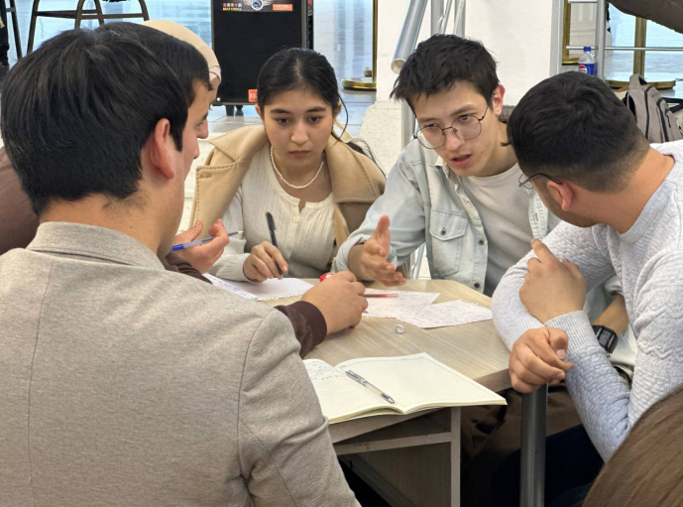

At the conclusion of the competition, the participants who achieved the best results were **evaluated by the panel of judges**, consisting of specialists responsible for organizing the event, **based on the criteria specified in the official regulations**.

### ****Based on the results, the Organizing Working Group RESOLVES:****

**According to the competition results, the following participants were declared winners:**

**1st place** — Team “Boylarga mazza”

**2nd place** — Team “Mon-Blan”

**3rd place** — Team “TUZ”

In accordance with **Order No. 85/11-08 dated February 22, 2025** of the University Rector, the winners of the 1st, 2nd, and 3rd places (as listed in the appendix) shall be **awarded diplomas by the university**, and in accordance with the regulation:

The **1st place team** shall receive a **monetary incentive equal to 3 times the basic scholarship**,

The **2nd place team** — **2 times the basic scholarship**,

The **3rd place team** — **1 time the basic scholarship**.

These incentives shall be funded from the university’s **student incentive fund**, formed from both **budgetary and extra-budgetary (tuition-based) resources**.

To further **expand intellectual initiatives**, ensure the **regular organization of “Zakovat” competitions**, and enhance **students’ social engagement**, these competitions shall be **held consistently** at the university.

**Head of the Working Group:**   **V. Sadiyev**  
**Secretary:**           **M. Sabirov**