REPORT
Regarding the “Zakovat Quiz” Intellectual Competition held within the framework of the “Youth Month” organized by the Primary Organization of the Youth Union at Uzbekistan State World Languages University

March 2025 Tashkent City
Chairperson:
V. Sadiyev – First Vice-Rector for Youth Affairs and Spiritual-Educational Work
Participants:
V. Sadiyev – First Vice-Rector for Youth Affairs and Spiritual-Educational Work, D. Khamdamov – Head of the Department for Youth Work, Spirituality, and Enlightenment, Coordinators of the Primary Organization of the Youth Union, Deputy Deans and Tutors.

ON THE AGENDA:
1. Conducting the “Zakovat Quiz” competition as part of the “Intellectual Projects and Reading Week” held within the framework of “Youth Month” at the university.
2. Discussion of the competition outcomes and awarding the winners.

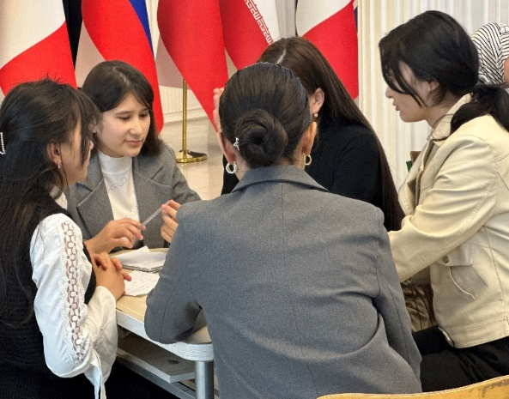
HEARD:
The Primary Organization of the Youth Union at Uzbekistan State World Languages University declared the period from February 25 to March 25, 2025 as “Youth Month”. As part of this initiative, an “Intellectual Projects and Reading Week” was organized to enhance students’ intellectual potential, promote reading culture, strengthen teamwork skills, and develop logical thinking abilities.
As part of this week, the “Zakovat Quiz” intellectual competition was conducted. It aimed to expand students’ knowledge, improve literacy in history, literature, culture, and science, and foster a friendly competitive environment among students.
The event was inaugurated by S. Islamova, who highlighted the importance of Youth Month, spoke about government reforms to boost youth intellectual development, and emphasized the growing popularity of Zakovat Quiz competitions in higher education. She also wished success to the participants.
A total of 20 teams comprising 140 students from various faculties took part in the competition. Participants engaged in lively debates, testing their knowledge against each other. The competition had 8 rounds, covering various fields. Students demonstrated skills in team collaboration, logical reasoning, quick decision-making, and broad knowledge.
Throughout the event, discussions were held in an atmosphere of friendship, knowledge exchange, and intellectual growth. At the end, participants shared their feedback and suggested organizing such events regularly with an expanded range of topics.

Based on the results, the Organizing Working Group RESOLVED:
According to the competition results, the following teams were declared winners:
1st place — “Boylarga mazza” team
2nd place — “Tuz” team
3rd place — “Cosmos” team
In accordance with Order No. 85/11-08 dated February 22, 2025 of the University Rector, the winners of the 1st, 2nd, and 3rd places (listed in the appendix) shall be awarded diplomas, and based on the regulation:
The 1st place team shall receive a monetary incentive equal to 3 times the basic scholarship.
The 2nd place team — 2 times the basic scholarship,
The 3rd place team — 1 time the basic scholarship.
These incentives shall be provided from the university’s student incentive fund, which is formed from both budgetary and non-budgetary (tuition) resources.
To expand intellectual projects at the university and to ensure that “Zakovat Quiz” competitions are held regularly with the goal of enhancing student engagement, these competitions shall be organized on a consistent basis.

Head of the Working Group: V. Sadiyev
Secretary: M. Sabirov

